Attempt LMS Online Quiz

- Login to LMS and open your course.

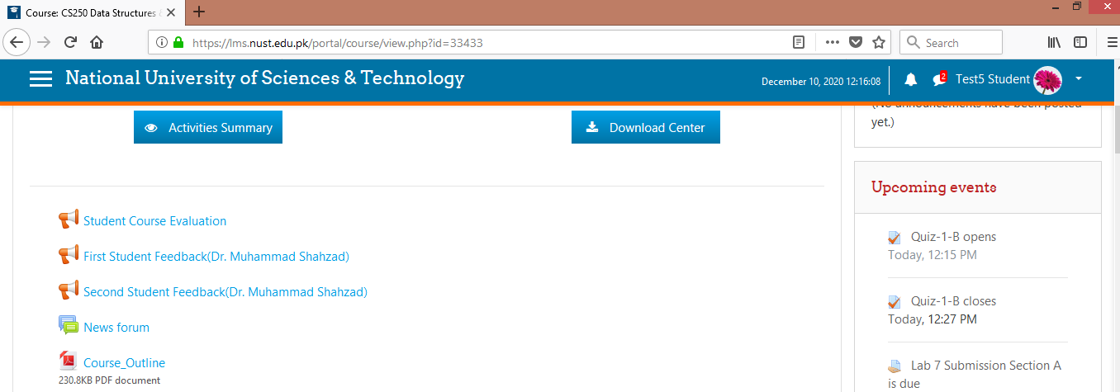

- Access the quiz activity in respective week of the course.

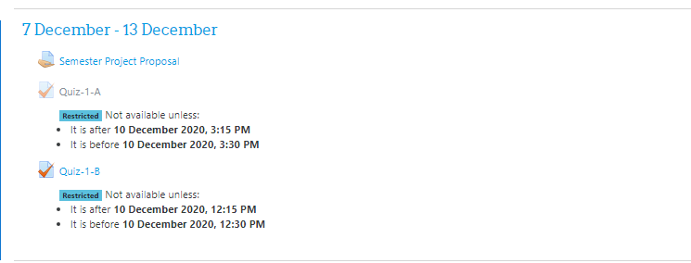

- The same activity can be accessed from the upcoming events block of the course.

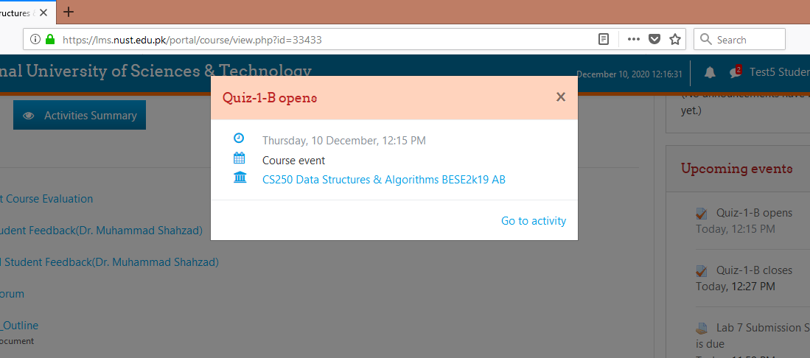

- Open the quiz, read the instructions carefully and click on “Start Attempt” button.

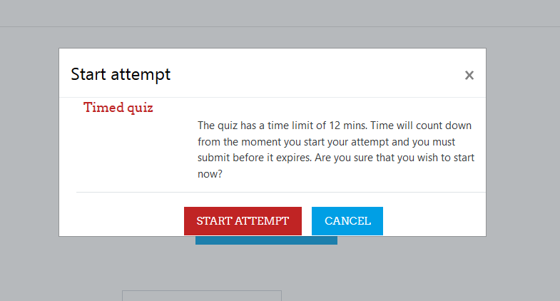

- Enter the password shared by the teacher (If the quiz is a password protected).
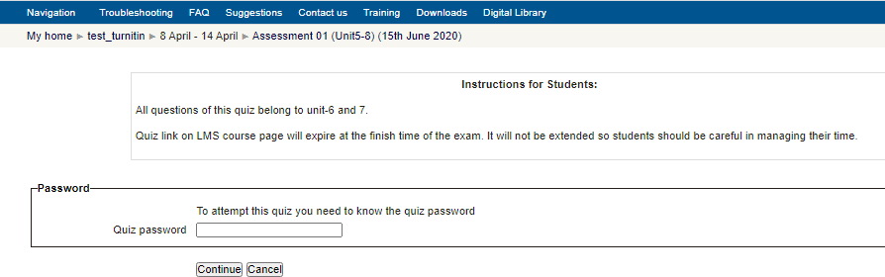

- Selest the correct answer and proceed to next question. (If teacher has set the “sequential navigation method” instead of the “free navigation method, then you would not be able to access previous questions).
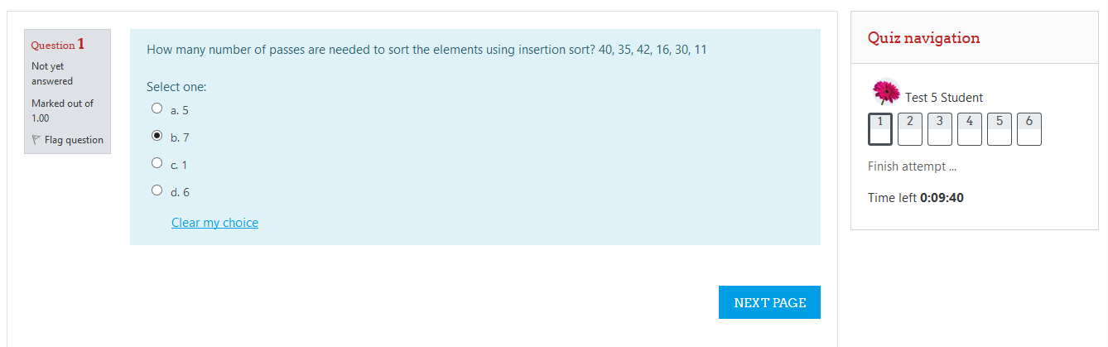

- Countdown timer in the quiz navigation block shows the time left for auto-quiz submission if you do not explicitly submit the quiz.

- All attempted questions are shown as half grayed rectangles.

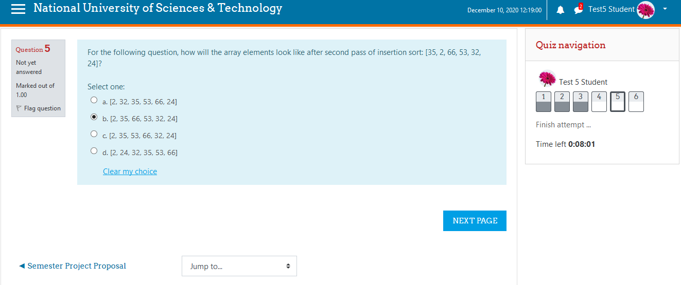

- Un-attempted questions will not gray-out. In case of free navigation allowed, un-attempted questions can be accessed anytime during the quiz.
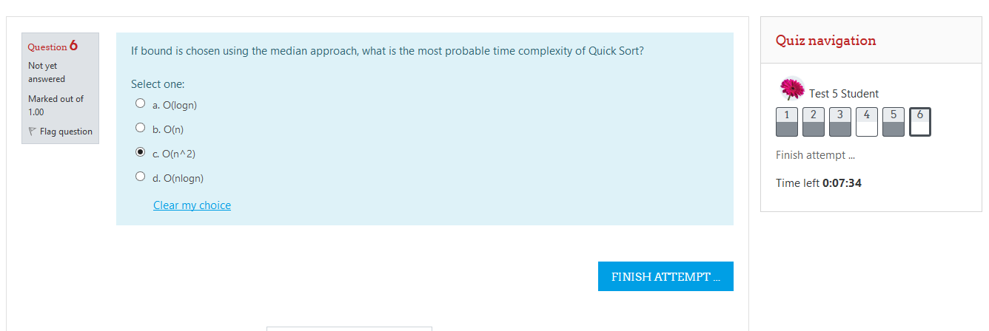

- At the end of quiz, summary of your quiz attempt will appear. You can either return to the quiz attempt or can submit your quiz and finish this activity.

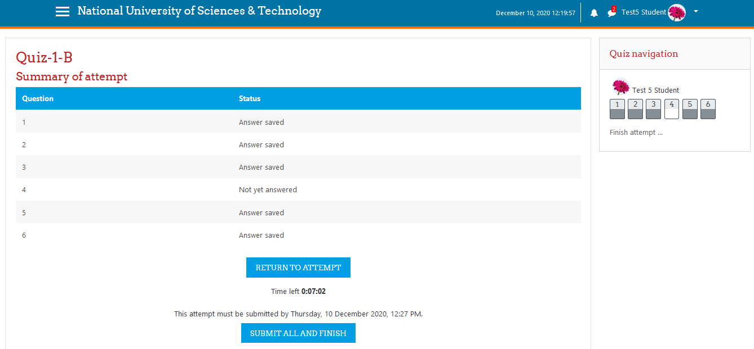

- You need to submit the quiz after reading the confirmation statement.





